PRE SEA DECK CADET TRAINING

LEADING TO CERTIFICATE OF COMPETENCY FROM
NEW ZEALAND

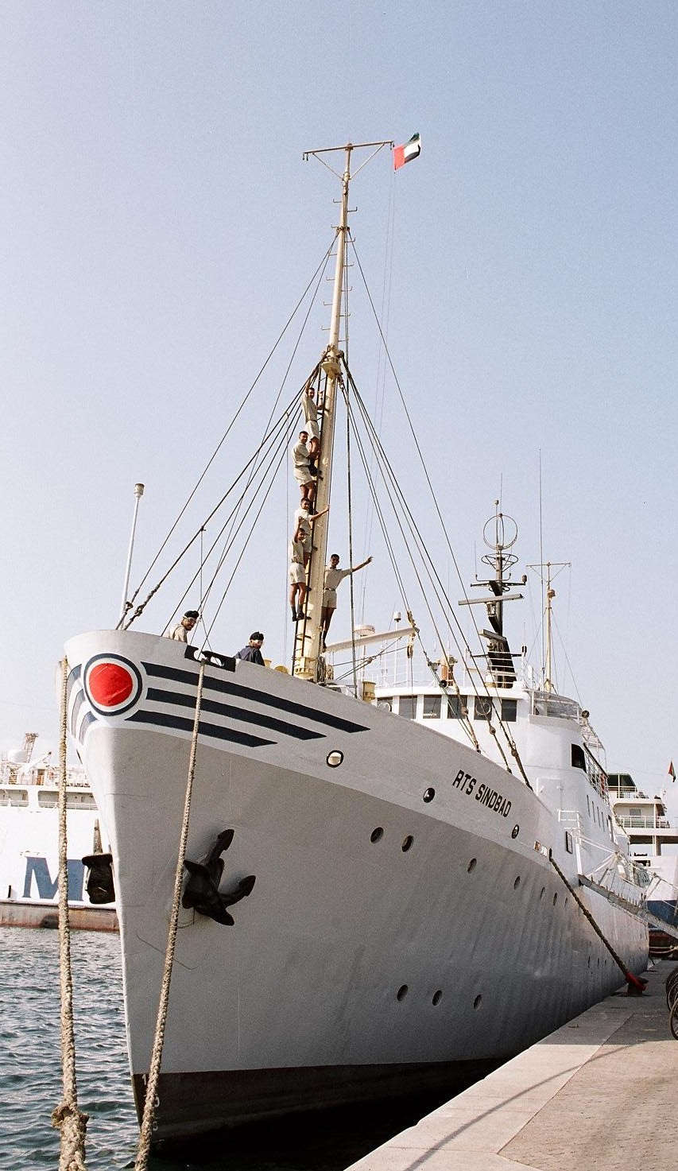

WINNER OF “SAILOR
TODAY” –INNOVATIVE
MARITIME TRAINING
AWARD (2006)
FINALIST FOR “LLOYD’S
LIST” – LONDON
TRAINING AWARD
(2007)

Our Mission :
NO MATTER WHERE
YOU STAND WE
SHALL LEAD YOU
TOWARDS A
GREATER ROLE . . . . . .

RAK TRAINING SHIP SINDBAD

THE COURSE BROCHURE

Certificate of Competency Class 3 (Deck) Program
WERE YOU AWARE THAT…….  Sea cargo transportation takes 99% of the world cargo market and leaves about 1% only (by weight) for the air transportation industry. The recent boom in the global economy has driven the sea freight market high and the order books of most of the world’s shipyards are full through the next 5 years.  There are 40,000 ships plying across the oceans, and numbers are expected to increase very fast. Each ship requires a Captain and three navigating officers. With the growing demand for new ships, there is expected to be a shortage of officers globally. Our course leads the students through a structured training program preparing them for their first professional certification at sea – Class 3 (Deck) Unlimited certificate.  COURSE OBJECTIVES:  At the end of this course, participants are able to safely, efficiently and competently carry out the watch keeping duties on board merchant ships both at sea and in port. They will be conversant with the basic principles as per STCW Regulations VIII/2 & STCW Code Chapter VIII.  COURSE CONTENT:  The course is conducted over 3 stages, as follows:  STAGE 1: Pre Sea Program (PSP)  3-months duration, conducted on board our training ship “RTS Sindbad” at UAE.  Modules:  Upon completion, trainees will be awarded the Certificate in Shipping and Transport (CST)  STAGE 2: Shipboard Attachment Program (SAP)  15-months sea going training on board merchant ships.  A Distance Learning Program (DLP) will be offered to all the trainees during this stage.  Modules:  Stage 3 – Certificate of Competency Class 3 (Deck) Unlimited  A 5-month preparatory program leading to the trainees obtaining their Class 3 (Deck) Unlimited CoC issued by the New Zealand Maritime Safety Authority provided they satisfy all the assessment and other criteria.  Entry Requirements:  - 10+2 or GCSE ‘A’ Level or equivalent with passes in Physics, Chemistry and Mathematics;  - Eyesight as per IMO Standards  - Age 18 to 22 years  Other Details:  Course Fee and Schedule:  Please contact for more information :  RAK TRAINING SHIP SINDBAD FZ LLC  CENTER FOR MARITIME STUDIES & SHIP MANAGEMENT  C/O RAK Investment Authority Free Zone  P.O.BOX 31291, Ras Al Khaimah, United Arab Emirates  Tel: +97172361842 Mob : +971506848713  Fax: +97172361843  Email: raktss@eim.ae / mail@e-nautical.com  Authorized Agent : | This course is accredited by Maritime NZ and conducted by Institute of Maritime Education & Training Pty Ltd, Australia.  The certification acquired is a world class certificate and in compliance with the requirements of the International Maritime Organisation as well as the relevant sections of the Standards of Training, Certification and Watchkeeping (STCW) for Seafarers, 1978, as amended.  RTS SINDBAD AT HIGH SEAS  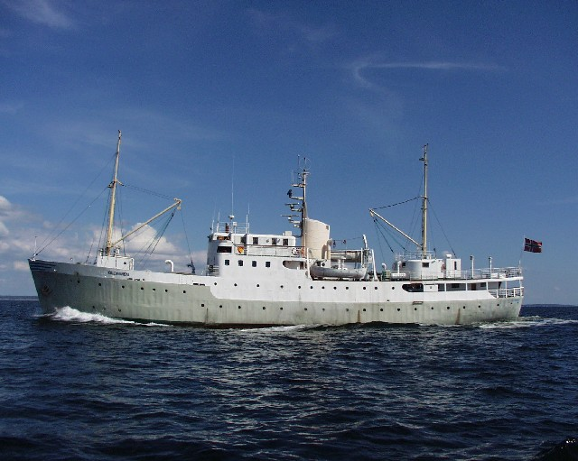  Build on strengths- own and others 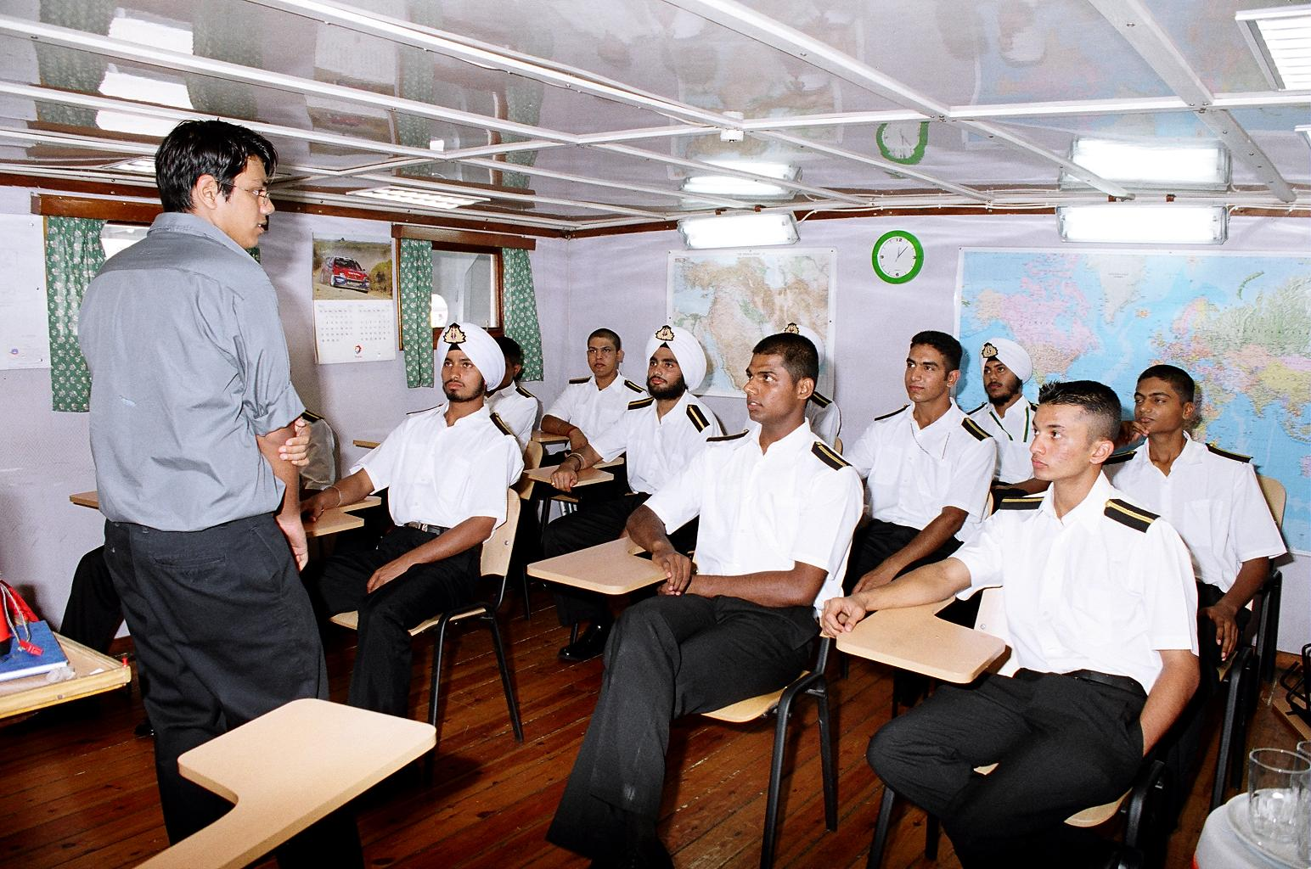  Core competency - NAVIGATION 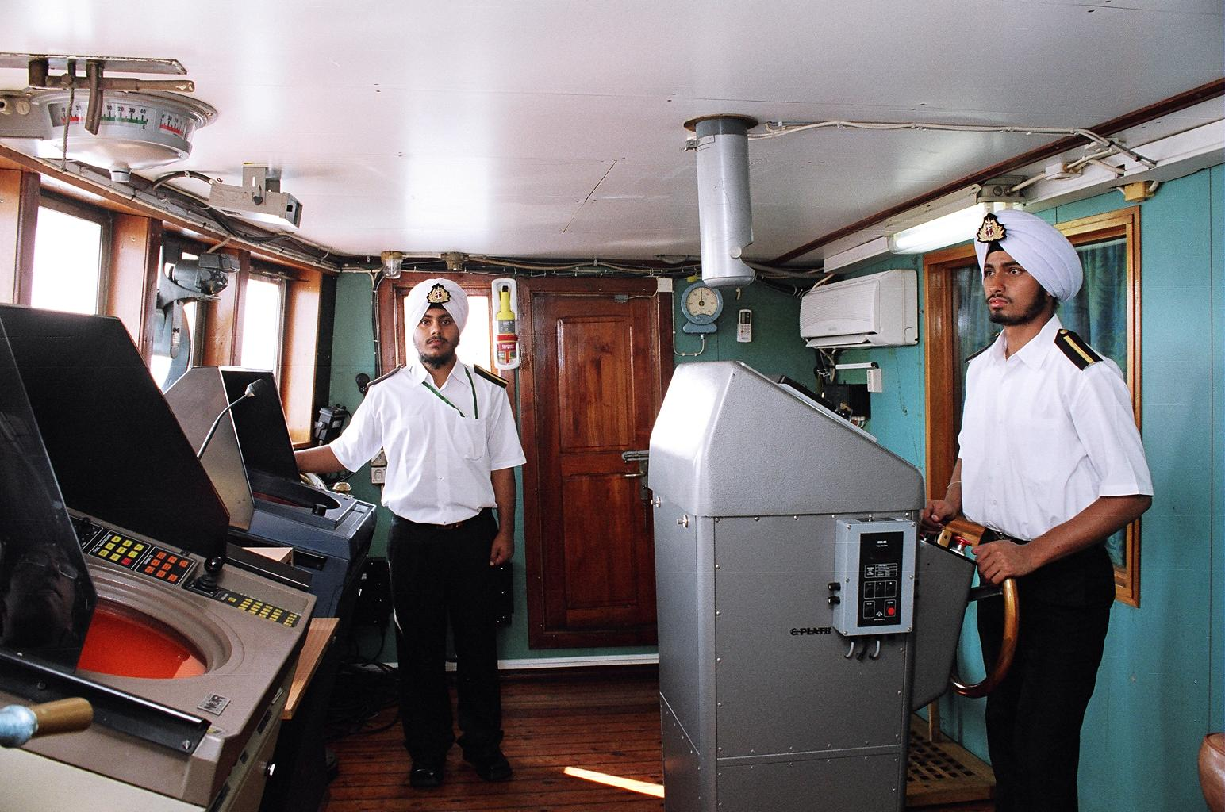  Core competency - CHARTWORK  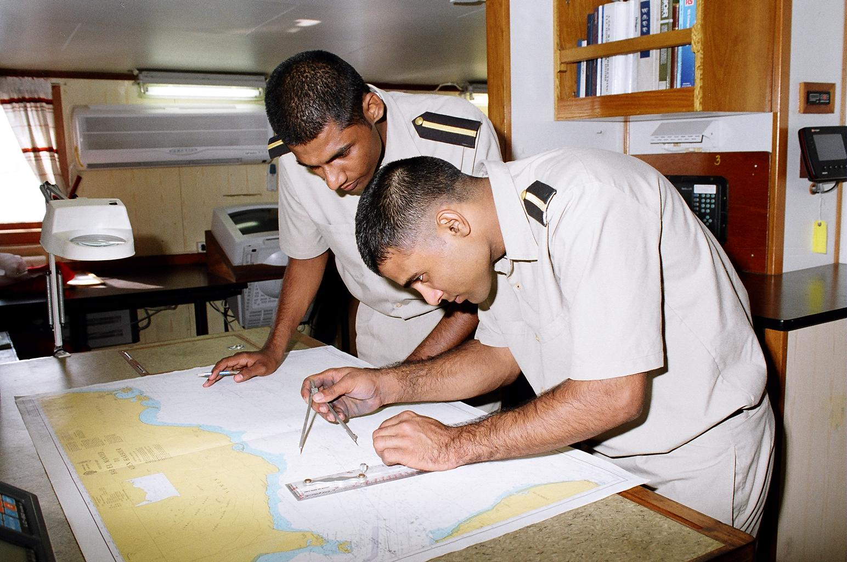  Core competency - SEAMANSHIP  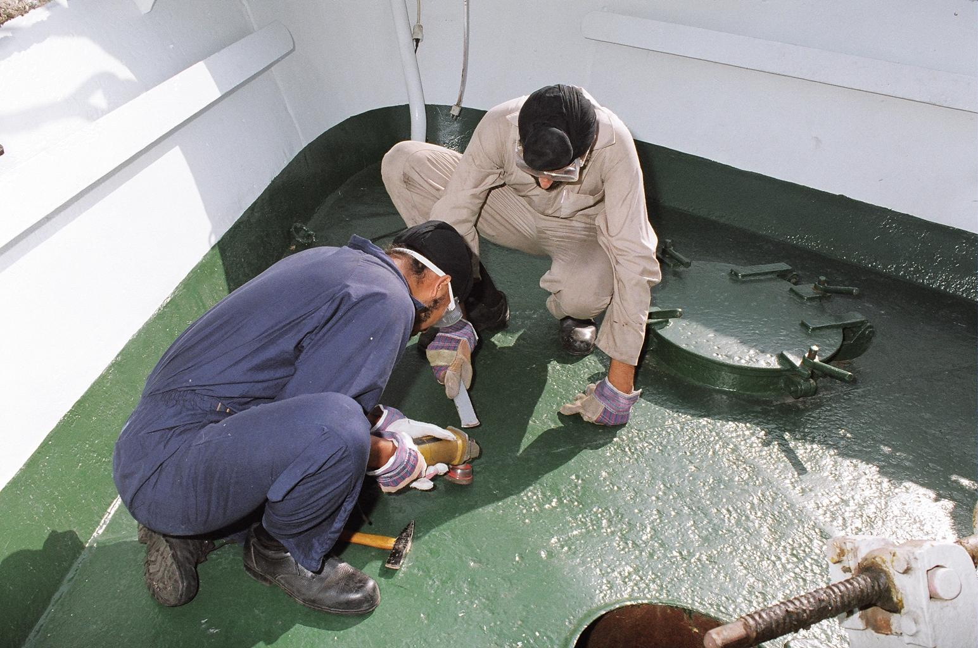  THE PASSING OUT PARADE 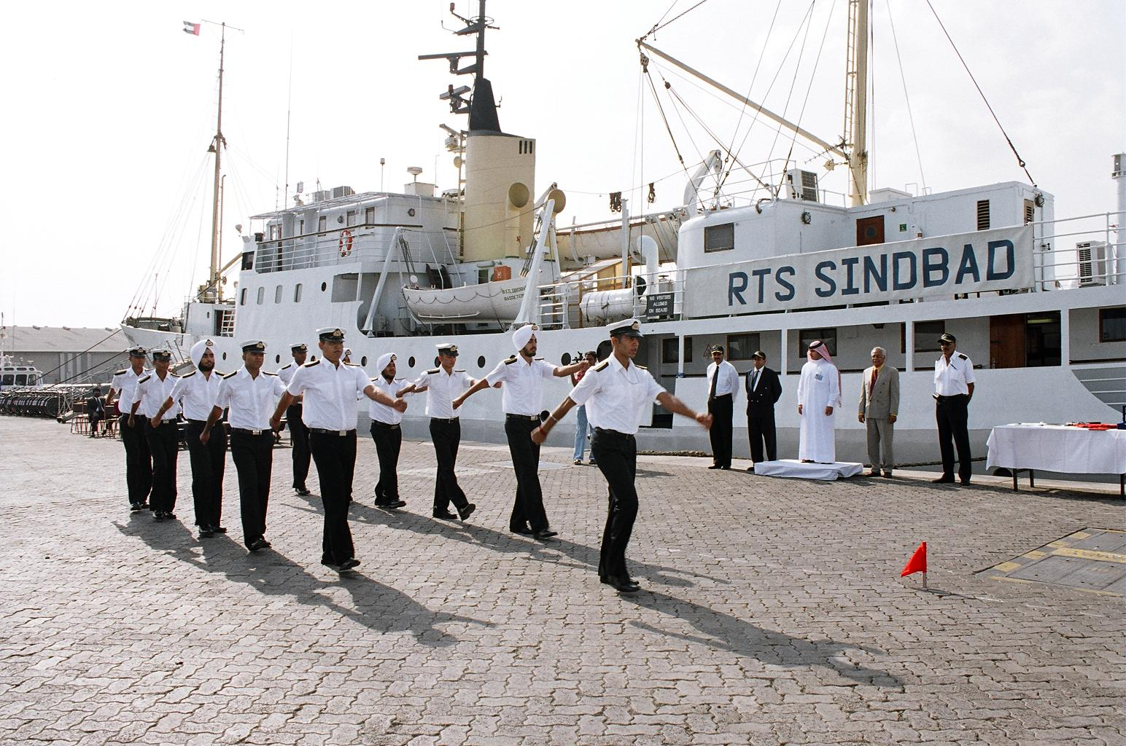  An Initiative synergized by  - RAK TRAINING SHIP SINDBAD  FZ LLC - CENTER FOR  MARITIME STUDIES & SHIP  MANAGEMENT  - ZAMBEZI SHIPPING AGENCY /  REEF SHIP MANAGEMENT  - IMETA / NEW ZEALAND  MARITIME SCHOOL  - e-Nautical / The Horizons /  Arch Ship Management /  Gurship / Gyansheel  - MARITIME ADMINISTRATION  OF ST. KITTS AND NEVIS  OUR VISION  To provide innovative Maritime Education and Training that makes a difference in the world.  OUR MISSION  We are fully committed in providing the best combination of practical & theoretical training leading our students towards a greater role.  OUR OBJECTIVES  Prepare students to attain high “Spirit of Performance”  -Exhibit high levels of integrity in their moral and ethical conduct  -Focus on results  -Build on strengths- own and others  -lead beyond borders, serving the common good.
  Code | Name
  PSP 001 | Ship Board Familiarity
  PSP 002 | Personal Sea Survival
  PSP 003 | Basic Ship Fire Fighting
  PSP 004 | Basic First Aid
  PSP 005 | Assist Bridge Watchkeeping
  PSP 006 | Mooring, Anchoring & Deck Watch
  PSP 007 | Vessel Operation & Maintenance
  PSP 008 | Cargo & Storing Operations
  PSP 009 | Electronic Navigational Aids
  PSP 010 | Ship Stability & Construction
  PSP 011 | Navigation
  PSP 012 | Meteorology
  PSP 013 | Introduction to Legislative Requirements
  Code | Name
  SAP 001 | Maritime Industry
  SAP 002 | Ship Construction
  SAP 003 | Stability and Stress
  SAP 004 | Cargo Work
  SAP 005 | Deck Watch keeping
  SAP 006 | Compass Work
  SAP 007 | Coastal Navigation
  SAP 008 | Celestial Navigation
  SAP 009 | Electronic Navigation
  SAP 010 | Plan Passages
  SAP 011 | Anti Collision Radar
  SAP 012 | Tidal Predictions
  SAP 013 | Meteorology
  SAP 014 | Bridge Watchkeeping
  SAP 015 | Vessel Operating Economics and Insurance Claims
  Duration | Class Size | Venue
  3 months | Up to 30 | UAE
  15 months | N/A | At Sea
  5 months | Up to 30 | New Zealand

